ESNEFT Referral form to Community Paediatrics

Please fill in all the sections with as much detail as you can. For helpful guidance and information on the referral process please visit the ESNEFT Community Website link or use the QR code below:
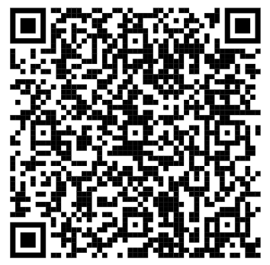
https://www.esneft.nhs.uk/service/childrens-services-community-paediatrics

Please ensure this form is fully completed and submitted together with any other required forms. Forms with insufficient information or incomplete will not be accepted.

Please send completed forms to:
compaeds-referrals@esneft.nhs.uk

Section 1: Reason for Referral and Consent
What is the primary reason for this referral? (please tick or mark yes)
Developmental delay in pre-school child
Physical disability, cerebral palsy or other complex health needs
Epilepsy in children with known neurodevelopmental problems
Sleep difficulties in children with a diagnosed neuro-developmental disorder only
Medication for ADHD (must have diagnosis)
Pre-school Social Communication difficulties / Autism
Autism (Include completed parent/carer form. If in education, also include completed school report form. Please see additional notes on next page.)
ADHD (Must be 6 years or older) (Include parent/carer form. If in education include school report form). Please see additional notes on next page.
Other:

CONSENT : Please tick
I understand that by completing this referral form, I am demonstrating that I have gained consent from the parent or carer, as well as the young person (if 16+), to refer for a neurodevelopmental disorder assessment.

For ADHD/ASD referrals has the parent accessed any early support through the Essex Local Offer? If YES please confirm which service has been accessed and when:  …………………………………………………………………………………………………… | YES  NO

Important information for all ASD / ADHD assessment referrals:

- All referrals must have a completed Parent/Carer form attached.
(If over 16, this can be completed by the young person, if they wish.)

- If a child or young person is in education all referrals must have a completed School report from the school or College/Sixth form attached.

- Please provide any other reports as supporting evidence (Eg. speech therapy or EP reports.)

- If there are no concerns identified in school, we encourage parents to access early support via the Essex Local Offer. Please see helpful links below.
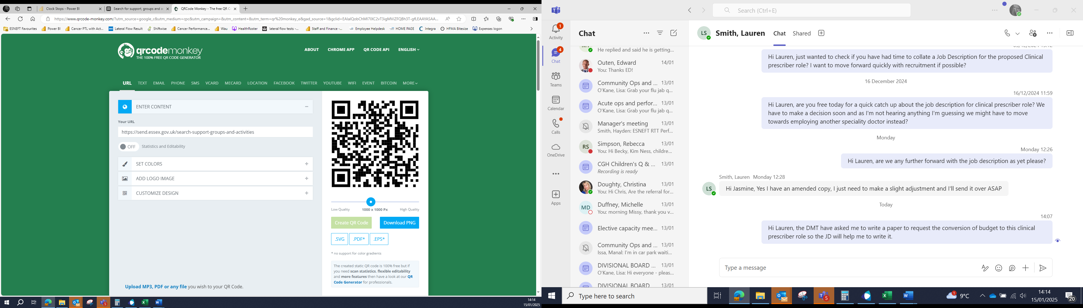
Essex Local Offer Website: https://send.essex.gov.uk

Essex SEND Support, Groups and Activities QR CODE:

Section 2: Referrer’s details
Name
Organisation and Job Title
Address
e-mail address
Phone number
Date of referral

Section 3: Child / young person’s details
First name
Surname
Date of birth
Birth gender and pronouns (if different)
Address (including postcode)
e-mail address
Phone number
Name of GP Surgery
Name of school / nursery
Main spoken language
Language(s) spoken at home
Interpreter required (yes/no)
Any current diagnosis / medical conditions
Previous assessments and dates for ASD / ADHD (yes/no).

This can include private or out of area. Please write details or attach report.
Any current medication

Section 4: safeguarding concerns
Is / was the child a Looked after Child in Care (LAC)? (yes or no) | YES / NO
Current Child Protection Plan (CPP) or Children in Need (CIN) Plan? (yes or no) | YES / NO
Is the child known to social care for safeguarding concerns? (yes or no) | YES / NO
If yes, please provide a summary of social care involvement including the name of the social worker if known in Section 5.

Section 5: Summary of presenting concerns or symptoms
Any other relevant information: For example, home setting, social factors, bereavement, parental separation, mental health, drug or alcohol issues

