  - North East Essex Neurodevelopmental Disorder Pathway
Guide for parents and carers



About this guide
This guide has been produced by Suffolk and North East Essex Integrated Care Board in collaboration East Suffolk North East Essex Foundation Trust (ESNEFT)
It aims to help parents and carers understand the Neurodevelopmental Assessment Pathway for children and young people living in North East Essex.
It contains the information that parent and carers have said they would have found helpful when they had a child or young person going through the diagnostic process for a neurodevelopmental disorder.

Who is this guide for?
This guide is for families of children and young people who may have a neurodevelopmental disorder.
It will help you understand the support available to your child or young person and family and explain how neurodevelopmental conditions are assessed and diagnosed in North East Essex.
“The human brain is as diverse as the human fingerprint.” A quote from Victoria McGovern.

What is neurodiversity?
Neurodiversity is not as simple as neat categories of traits and symptoms in clear diagnostic boxes. Neurodivergent conditions exist on a spectrum, a scale of increasing severity or impact of the differences associated, at the extreme end of which a young person may meet current diagnostic criteria for a particular condition.
For example, social communication difficulties exist along a spectrum, at the extreme end of which some people may meet diagnostic criteria for autism. Similarly, attention and hyperactivity problems exist along a spectrum, at the extreme end of which some people may meet criteria for a diagnosis of ADHD.
When we talk about neurodiversity in childhood, we’re not talking just about young people who fit into the diagnostic bubble at the end, but about a broader range of neurodivergent young people whose brains work differently, who have unique strengths and find some aspects of life really challenging.

Neurodiversity Spectrum
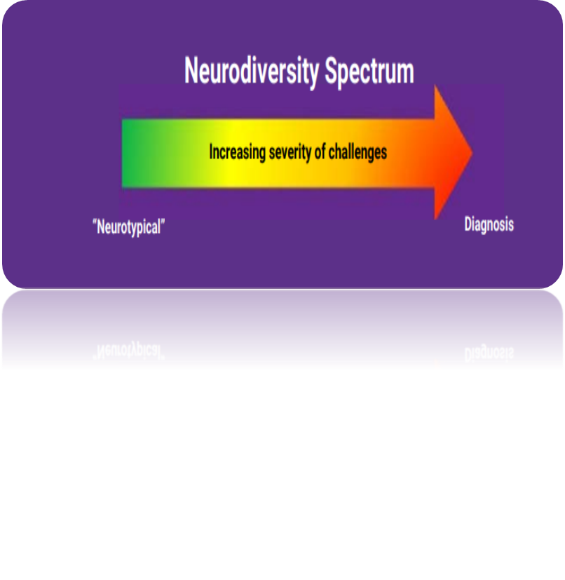
Figure 1. The Neurodiversity Spectrum is a graphic with left to right arrow showing ‘increasing level of challenges’. ‘Neurotypical’ on the left, to Diagnosis on the right.

What does neurodevelopmental disorder or condition mean?
A neurodevelopmental disorder (NDD) or neurodevelopmental condition is a term used for individuals where learning, attention, emotions, impulses, sensory processing, and social behaviours can be at an extreme, which impacts their ability to perform tasks and activities in their daily lives.

What is Autism?
Autism or an autism spectrum disorder (ASD) is a lifelong neurological difference that affects how people communicate and interact with others. Most autistic people see, hear, and experience the world differently from neurotypical people, but like neurotypical people, every autistic person is unique and complex.
It is clear that everyone is completely different and has different strengths and weaknesses. For example, one autistic person may be highly creative, but struggle to organise themselves. Another may excel at maths but find it hard to join in two-way conversations.
This graphic below shows that when a person is on the autism spectrum, they may demonstrate great strengths in some areas but be lacking in skills in another.
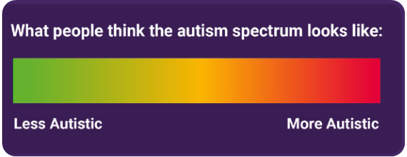
Figure 2. ‘What people think the autism spectrum looks like’ shows a simple scale of ‘Less Autistic’ to ‘More Autistic’
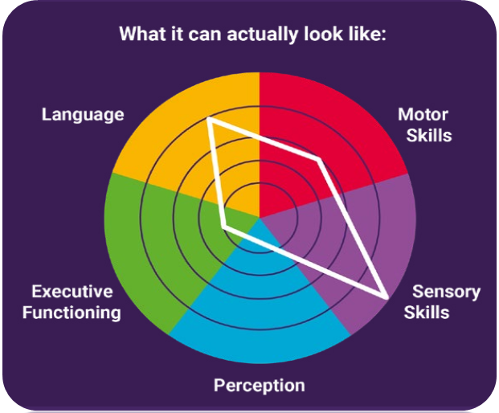
Figure 3. ‘What the autism spectrum can actually look like’ shows a more complex and nuanced scale including perception, executive functioning, language, motor skills and sensory skills.

More information on autism
For more information on autism, as well as advice and guidance on local support and resources, please visit the Essex Family Forum website.

What is ADHD?
Attention Deficit Hyperactivity Disorder or ADHD is a neurodevelopmental disorder where individuals have difficulty regulating their attention because of poor neurotransmitter activity (the way chemicals are released and transferred within the brain) and differences in the structure of the brain. Attention Deficit Disorder or ADD is similar, but without the hyperactivity.
ADHD usually presents in three different ways, hyperactivity (which means the need to move around more), impulsivity and inattention as well as sensory processing challenges. It means that children with ADHD may not always be able to control their behaviour. These are the main features of ADHD but there are many more that have a significant impact on a child’s organisational skills and emotional well-being.

More information on ADHD
For more information on ADHD please go to the Essex Local Offer website.

I think my child or young person has a neurodevelopmental disorder, what happens now?
The next steps are different for each child or young person and their families, this means that timescales can be different between individuals. Over the following pages you will find information that shows you the pathway and the potential outcomes at each stage, as well as information about the variety of services that can support you and your child or young person.
This booklet will provide details of these services and how you can access them.
If you have any concerns about your child or young person, then trust your instincts. You know them better than anyone else and are their greatest advocate.


The neurodevelopmental Disorder pathway

Overview of the diagnostic pathway and what to expect

First steps
- You may have a sense that some of your child’s reactions seem to be extreme or excessive, or don’t follow similar development patterns of other children their age.
- Sometimes you might have support from those around you, but if you feel that staff at school/ preschool, family members and friends see things differently and dismiss your concerns then talk to another professional such as your GP, health visitor or a trusted member of staff from school/pre-school.
- Not all families will want to seek a diagnosis and that is ok, it is an individual family choice.
- Sometimes it can be that you are not the first to notice differences. Some parents will naturally make adjustments to their own communication and interaction with their child to compensate, without realising, especially if there is no sibling for comparison. For younger children, sometimes the first difference you or others become aware of is their delayed communication.
A diagnosis of Autism or ADHD requires the child or young person to have difficulties in key areas which impacts their ability to perform tasks and activities in their daily lives:
- Language and Communication
- Social Interactions
- Play
- Friendships
- Attention
- Emotions
- Behaviours (for example, restricted or rigid patterns of interest)
These difficulties need to have been present for a significant amount of time, rather than due to a specific event, and present across different settings such as home and school.
Many difficulties associated with ASD and/or ADHD, can be due to other causes, for example, speech and language difficulties, learning needs, emotional difficulties, and hearing impairment and these assessments can be accessed while waiting for an ND referral, such as:
- Speech and Language Therapy
- Occupational Therapy
- Audiology
- Child and Adolescent mental health teams
- Educational Psychology
This is so they receive the right interventions and support as their needs arise.
If you are concerned that your child may have difficulties in their learning and may need additional support at school, the first step would be to talk with your school’s SENCo and/or teacher to discuss further steps.
Similarly, if you are concerned that your child is socially anxious, it would be beneficial for them to receive an assessment from a Child and Adolescent Mental Health team.

Important to know
Diagnosis is not necessary to access a wide range of locally commissioned support services. Access to these, and strategies known to be useful for children and young people with neurodevelopmental needs can be found below as well as on the Essex Local Offer website.
It is NOT necessary to have an ASD and/or ADHD diagnosis to apply for an Education Health Care Plan (EHCP), nor does a diagnosis of ASD and/or ADHD mean that a child will require an ECHP.

Support available
The Essex Family Forum have devised a resource pack; Supporting your neurodivergent child.
This resource has been devised by parents who have shared their own experiences, tips, and best practices, along with many other families across Suffolk and Essex to aid you on your own journey.
The pack provides an overview of what has been found to be the most relevant information from sources such as the NHS and local websites, national and regional charities and Independent Provider of Special Education Advice (IPSEA). There are also links included on specific topics so you can find out more as well as recommendations of books, videos, blogs and resources that we have found useful.
All families can access:
- Children’s Centres, GP’s, Health Centres, School Nursing, Education and funding for early education.
- SEND Local Offer
- Early Help - support that improves a family’s resilience and outcomes or reduce the chance of a problem getting worse
- Local parent and carers workshops
- NDD Resource pack and resources
No diagnosis is necessary to access these services, however some require a referral from a professional and may have eligibility criteria.

The Diagnostic Pathway
We recognise that for children, young people, and their families, that waiting for a referral appointment can be an incredibly worrying and confusing time, as it is often unclear who is involved at what stage of the pathway and who families can contact if they have any questions.
In North East Essex, there are currently two pathways:
- The Under 5’s ASD Pathway
- The NDD pathway for Children and Young People between the ages of 5-18 years old (up to their 18th birthday).

Diagnostic Pathway for Under 5’s
- Differences with regards to your child's development? Speak with a Health Visitor or Early Years Setting (pre-school or nursery).
- Health visitors or Early Years Practitioners can refer to ESNEFT (East Suffolk and North East Essex Foundation Trust) where there are significant developmental delay or social skills difficulties, this would include consideration for an ASD assessment.
GP and speech therapists may also be able to refer
- Referral is made to ESNEFT using the ESNEFT Community Paeds Referral form.
- Local voluntary services providing support, information, advice & guidance can be accessed via your Early Years Practitioner or Health Visitor.
NICE Guidelines advise that ADHD should not be assessed until ages 6+ due to development milestones and because the treatment medication is not recommended to be prescribed under this age. Therefore, please note the North East Essex Community Paediatric Service do NOT assess for ADHD in under 6-year-olds.

Pathway for Children in Education from 5-18 years

Referrals for ADHD or Autism can be sent by a School/College/GP and other lead professionals but it must be received together on the following completed forms:
- ESNEFT Community Paeds referral form

- Parent Form

- School Report (if the child is in education)

If the child is not in Education or is home schooled, then a School Report is not required.

A referral will not be accepted if:
- ADHD referrals for a child who is under 6 years old.
- Old forms continue to be used after 1st March 2025
- The necessary forms are not submitted together, or
- If the information provided is not sufficient to meet the criteria for acceptance

These forms and the guidance on how to complete them can be found and downloaded on the ESNEFT Community Paediatric Website: Community child health referrals for neuro-development - East Suffolk & North Essex NHS Foundation Trust (esneft.nhs.uk)
The Community Paeds referral form will need to confirm if the request is for either a diagnostic assessment for autism or ADHD, so it is best to consider your child’s primary needs and/or differences.
For example, if your child’s primary needs are in relation to difficulties or differences in their communication, social interactions and rigidity, an autism assessment is likely to be the most appropriate request. However, if your concerns are more in relation to attention and concentration difficulties, hyperactivity and impulsive behaviours, an ADHD assessment would more likely be appropriate.
For more information of signs and symptoms of autism and ADHD, please see the NDD support pack
On both parts, you and the professional who knows your child best; will be asked to provide information and examples of any strengths and/or difficulties they may have in the following areas:
- Communication
- Social interactions
- Rigid behaviours, thinking and special interests
- Sensory
- Attention and concentration
- Hyperactivity
- Impulsivity
- Any other current concerns
You will also be asked to share some information about your child’s education as well as medical and developmental history.
Make sure to try and include examples within your referral and not just a list of symptoms and/or behaviours. We want to know what life is like for your child.
A good example:
“Thomas frequently finds it difficult to look at people when he is talking to them or when they are talking to him. He will often not look directly at them but look out the corner of his eyes or sometimes in a different direction. This is more noticeable when he is talking to unfamiliar people or is in a new environment. Thomas does make eye contact with those he is comfortable around.”
A poor example:
“Thomas does not make eye contact.”
For ADHD referrals you and the school will also need to complete SNAP IV screening questionnaires.
Along with your referral form you can submit any support evidence that you feel may be useful to the assessment process.
This may include (but not is limited to):
- School Observations
- Child/Young person’s own views
- Previous Medical report (where relevant)
- Speech and Language Therapist Report
- Occupational Therapist Report
- School Nurse or Health Visitor Report
- Educational Psychologist Report
- CAMHS/LDCAMHS/Other specialist CAMHS
- Tertiary hospital reports
- EHCP/education provision Agreement/support plan
- Individual Education/Behaviour Plan (or equivalent)
- Early Help Assessment
- Personal Education Plan for LAC Child
- Behaviour Intervention/Youth Offending Team Report
- Children’s Social Care Report

The Referrer: who can act as one and what is their role?
The referrer should be the individual with the best professional knowledge of the child or young person, who knows them and their family well. This could ideally be someone from the child’s school setting, such as teachers and/or SENCOs but can also be a health professional such as a GP or mental health nurse from CAMHS.

The role of the referrer:

It is the referrer who holds the primary responsibility for the child or young person’s care and for communicating and actioning any onwards referrals and recommendations following the submission of an ASD/ADHD assessment request.
For example, if further information is requested, it would be the role of the referrer to ensure that sufficient evidence is provided so that the referral can be processed.
Similarly, if a recommendation from the referral triage is that the child accesses a specific support service, it is the referrers’ role to ensure that the family are supported in doing so.
Suggested professionals to make the referral could include (but is not exclusive to):

Suggested professionals to make the referral could include (but is not exclusive to):
- Special Educational Needs Coordinators (SENCO)
- Tutors or Teachers at schools or colleges
- Educational psycho Specialist Education Services (if accessing)
- Alternative Tuition Service (if accessing)
- Elective Home Education Team
- Private Tutor.
- GP
- School Nurse
- Health Visitor
- Paediatrician
- Psychiatrist
- Nurses
- Clinical, counselling, or forensic psychologists
- Occupational therapists
- Speech and language therapists
- Primary mental health worker
- Mental health professionals.
- Social worker
- Early help practitioner
- Family support worker.
In addition to the above, sources of evidence can also be provided by:
- a paid carer
- relative or friend
- information from their previous education placement may also be considered as part of the support evidence.
They are available to download on the ESNEFT Website n either paper or digital format. Paper forms can be printed, handwritten, scanned and sent to us by email as an attachment. The digital version allows you to type into, save the file and send by email as an attachment.

- ESNEFT Community Paeds Referral Form

- This form needs to come with any Community Paeds referral to ESNEFT, whether for Neurodiversity (Autism or ADHD assessment) or Neurodisability.
- This is for children aged 5 – 19 years for those either in or out of education.
- The referrer should be the most appropriate lead professional for that young person which could be School/Education Services (if accessing), Elective Home Education Team Social Worker/ Family Support Worker, Speech Therapist, Family Support Practitioner, GP, Primary Mental Health Worker, mental health professionals.
- This form must be submitted along with the completed Parent carer form (and School report if in education) to compaeds-referrals@esneft.nhs.uk

- Parent/Carer Form

- This form needs to be completed by the parent/carer of the child.
- If a young person is over 16 they can choose to complete this form themselves, only completing the sections that are relevant with the information they know.
- This form needs to be submitted along with the ESNEFT Community Paeds Referral form if the referral is for Autism or ADHD.
- We can only accept a neurodiversity referral if both forms are received together to compaeds-referrals@esneft.nhs.uk otherwise it will be returned as rejected.

- School Report Form

- This form is compulsory for a School to complete to send with any referral for Autism or ADHD assessment. This form needs to be received if the child is registered in a school or college, aged 5-18 (even if they are not currently able to attend).
- If the child is not in Education or is home schooled, then a School Report is not required.
- Section 4 and 5 do not have to be completed if the information has already been given in the previous sections.
- They should be completed by an individual with the best professional knowledge of the child or young person, who knows them well.
- A college who does not know the child well enough does not have to complete Section 2 if they don’t have that information.
- This form must be submitted along with the completed ESNEFT Community Paeds Referral form and Parent carer form to compaeds-referrals@esneft.nhs.uk

Once a referral form and supporting evidence has been received it will be reviewed/triaged by one of our Community Paediatric team to ensure it is complete and enough information has been provided.

What happens next?
If the Autism or ADHD referral is accepted:
We add the child to the waiting list. We send a letter to you to confirm that we have accepted the referral.
Please note that current wait times are long, please refer to our current updated wait times by clicking here: Children's neuro-development first appointment –
While you wait to be seen, you can access support for you and child. We have information about support organisations on these pages:
- Support for neuro-developmental disorders
- Children’s support in Colchester and Tendring

If an Autism or ADHD referral is not accepted:
All referrals are triaged, but not all will be accepted based on clinical criteria.
If your referral is not accepted, you can still access support. We will send you a letter to confirm that the referral has not been accepted and will guide you to get in touch with the Essex Local Offer.website. This holds lots of information on how to contact organisations to get access to help and support for your child.
If the situation changes or symptoms become worse then parents can request a re-referral again later but will need to evidence that they have attempted to access some of the support from organisations in the Essex Local Offer. first.

ADHD
If the original referral has definite indicators that your child or young person could have ADHD, they may be asked to come in for a QB test, which is usually prior to being seen for their first appointment and involves a 15 to 20 minute computer based test.
You and the child’s school may also be sent a SNAP questionnaire to complete 8 weeks before the appointment. It is very important that you complete and send this back in the timeframe.
In the first appointment with the doctor, the child’s full history will be discussed and the QB results reviewed. A diagnosis may be able to be given in this appointment, unless further assessment is required (such a school visit).

ASD
If the original referral had requested an assessment for ASD, the first appointment could be booked with any of the following clinicians:
- Doctor
- Specialist ASD Nurse
- Specialist Speech and Language Therapist
- Clinical Psychologist
The child’s full history will be discussed, and a decision will be made then as to whether the child is suggestive of ASD and should go on the waiting list for ASD assessment.
This further assessment could involve a school visit, Speech and Language (SALT) clinic appointment or an Autism Diagnostic Observation Schedule (ADOS) assessment and can be a further wait of up to one year. Following this assessment, a follow up appointment with a doctor will be made 6 to 8 weeks later to be given the outcome.
Note: If the child or young person’s presentation could potentially be explained by something else, then the recommendations will be made to access other support services.

Demand for services
There is currently an unprecedented demand and backlog for diagnostic services for both ASD and ADHD assessment in Essex. This has meant that any new referrals into the service may take over a year before assessment.
Please be assured that the ICB and commissioned service providers within the neurodevelopmental disorder pathway, are committed to reviewing and developing the local delivery and protocols for pathways for children and young people with neurodevelopmental disorders.

Advice from parents and carers

Keep a diary
When you are speaking with professionals about your concerns, or you are providing information for a referral it helps to have kept a diary of your experiences and why you are concerned.

Don’t compare your child to someone else’s
The way your child’s development progresses is different to another.
Neurodevelopmental disorders are a spectrum and whilst there are distinctive characteristics that must be present to obtain a diagnosis, how they present in your child or young person and the impact they have on their development will differ between individuals.

Talk to others and try not to become isolated
Families often say they felt alone when their child or young person was initially identified as having a neurodevelopmental need, especially where the child or young person displayed challenging behaviour.
There are several voluntary organisations across Suffolk that are ran by parents of children with a neurodevelopmental disorder who will be happy to have a chat with you about their experience and what techniques they found helped their child or young person. Information about these services can be found on the SEND Local Offer website.

Take notes
When you are attending appointments with clinicians you will likely be provided with a lot of information, and it can be overwhelming.
If you can, take a pen and paper and write down anything of significance as this will help you remember at a later point.

Ask questions
You will have lots of questions throughout the process and it is never a wrong time to ask them. Sometimes it is helpful to write these questions down, so you do not forget them when you are attending an appointment with clinicians.
If there is more practical help you are needing, you can access services through the SEND Local Offer. Even if the person you speak to doesn’t know the answer, they will know someone who will.
Tip from a local parent: “Buy a big folder and start keeping a copy of everything, literally everything, to build a complete picture of your child. My son bit a child at school, and the teacher spoke to me on the school gate, at the time I was upset and couldn’t really focus on what they were saying so I asked them to confirm in writing and this was actually really useful information when I spoke to my GP about my son’s difficulties”

Access training courses and resources
Lots of organisations provide free training for parents and carers of children and young people with neurodevelopmental disorders and how to meet their needs. Some are specific to a particular diagnosis such as ASD or ADHD, but others are topical such as sleeping or toileting.
You will also find lots of tips and advice in the Essex Resource Pack.

You do not need a diagnosis to access the support you and your child or young person need
The prevalence of neurodevelopmental disorders is increasing, this means that the length of time you are waiting for a diagnosis may be long.
However, access to support for you and your child or young person's needs is not reliant on a diagnosis.

Useful contacts
The following is a list of useful contacts and agencies that may be able to provide you with further information and support during this time.

Neurodevelopmental Disorders Early Support in Colchester and Tendring

SEND Information Advice & Support Service (SEND IASS)
We provide free, confidential and impartial information, advice and support about Special Educational Needs and Disability (SEND) for children and young people (0-25), parents and carers.
Website: www.essexsendiass.co.uk
Phone: 01245 204338
Email: send.iass@essex.gov.uk

Autism Anglia
We support families with autistic children to navigate clinical and non-clinical services, including diagnosis, health, educational, social and financial support.
Website: www.autism-anglia.org.uk
Email address: communityconnect@autism-anglia.org.uk
Phone: 01206 577678

Essex Child and Family Wellbeing Service
Neurodevelopmental Pathway Coordinators support ages 0-25 with neurodevelopmental conditions, such as Autism, ADHD, and Dyspraxia, providing consistent individualised information, resources, and support.
Website: www.essexfamilywellbeing.co.uk
Phone: 0300 247 0013 (Monday to Friday 9am to 5pm)

Families InFocus (Essex)
Providing advice, support, and information to families with SEND children on education, disability benefits and other areas of support.
Delivering weekend activity clubs in Colchester and Chelmsford for SEND children and their siblings.
Website: www.familiesinfocusessex.org.uk
Email Address: helpline@fifessex.org.uk
Phone: 01245 353575 (Monday – Friday 10amto 4pm, with 24-hour answerphone)

The MAZE Group (North East Essex)
The Maze Group have a unique approach to SEND which offers insights into how children with additional needs experience the world. They have free monthly coffee mornings in Colchester, Clacton-on-Sea, Mistley and Harwich and a specialist weekly programme available online through a video series and face-to-face in Colchester, Clacton, and Harwich.
The Maze Group also offer a course on navigating the SEND system.
They also provide specialist support for parents who have additional needs. Their aim is to guide, advise and support you for as long as you need.
Website: www.themazegroup.co.uk
Phone: 07809 900161 or 07708 873023
Email Addresses: amanda.towns@themazegroup.co.uk and sue.anderton@themazegroup.co.uk

Essex Family Forum (Essex)
A Parent Carer Forum (PCF) which ensures services in their area meet their needs and improve outcomes of children and young people with Special Educational Needs and Disabilities (SEND) and their families.
Share your experiences via the online Graffiti Wall on the website or send an email.
Website: www.essexfamilyforum.org
Email Address: hello@essexfamilyforum.org
Graffiti Wall: www.essexfamilyforum.org/have-your-say/feedback-wall

Supporting Your Neurodiverse Child – Resource Pack (Essex Family Forum)
Supporting Your Neurodiverse Child is a pack that is available to all parents and carers and includes information about Neurodiversity, the diagnostic process, information on support for your child at school, sensory needs, emotional regulation, health, and wellbeing and much more.
The pack is available to download, or you can request a hard copy to be delivered to you via the website.
Online: www.essexfamilyforum.org/resources/nd-pack
Email Address: hello@essexfamilyforum.org

Emotional Wellbeing and Mental Health Early Support in Colchester and Tendring
The Suffolk and North East Essex Integrated Care Board (SNEE ICB) and the Start Well Domain have provided grants to 17 local projects, to help deliver support between 2023-2025. For information about these projects or the organisations’ other services, please view their websites.

Bridgeway Mission (Colchester)
A safe and supportive network for children refugees and their families, improving wellbeing and confidence.
Website: www.bridgewaymission.com

Changing Lives (Colchester)
A combination of free physical activity and mental health sessions, including the use of gym, nature, and animals.
Website: www.changinglivescommunityservices.co.uk

Kids Inspire (Colchester)
Talk Together provides tailored support from early intervention to complex and extremely complex needs for 0 to 18, up to 25 with SEND and their families.
Website: www.kidsinspire.org.uk

Underdog Crew (Colchester)
Free training for young adults with lived experiences of mental health issues, autism and neurodiversity through film making and employability skills.
Website: www.megalodonstudios.co.uk

Active Essex Foundation
A sport and physical activity project for children and young people aged 5-18 years.
Website: www.activeessexfoundation.org

Connect Without Limits
A safe and supportive network, including counselling, mental health support and autism friendly activities.
Website: www.cwlcic.com

Essex Wildlife Trust
A Wild Wellbeing programme, with mental health support through positive wellbeing activities outdoors.
Website: www.essexwt.org.uk

InterAct
Early intervention and personalised support service for parents and carers of children and young people with any disability and/or additional needs.
Website: www.interact.org.uk

Wilderness Foundation UK
A nature based Brave Futures wellbeing programme for children and young people aged 4 years and older.
Website: www.wildernessfoundation.org.uk

Youth Enquiry Service
School navigator and one to one counselling sessions across 15 settings for young people.
Website: www.yesyouthenquiryservice.org

Citizens Advice Tendring (Tendring)
Taking their domestic abuse and family advice service into the heart of the local communities.
Website: www.cabtendring.org

EXTRA (Tendring)

A rolling programme for parents/carers whose children are undertaking or waiting for counselling.
Website: www.extrasupportforfamilies.co.uk

Home Start (Tendring)
Pop up groups to support vulnerable children 0-11 years and their parents.
Website: www.home-startcjc.com

Lads Need Dads (Tendring)
A family support worker signposting and offering emotional support to mums and carers of boys taking part in Lads Need Dads programmes.
Website: www.ladsneeddads.org

Tendring Families First (Tendring)
A range of therapeutic and creative interventions for children aged 5-11 years to self-manage mental wellbeing.
Website: www.tendringfamiliesfirst.org

The Ark Family Resource Centre (Tendring)
Weekly therapy sessions for children 5 to 16 years, outreach and joint child and family sessions.
Website: www.thearkcentre.wordpress.com

The London Bus Theatre Company (Tendring)
Jaywick The Musical – Drama and film making project engaging young people in Tendring.
Website: www.londonbustheatre.co.uk

