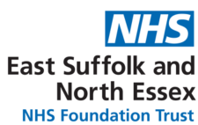
WORKFORCE RACE EQUALITY STANDARD (WRES)
2024/25 ANNUAL REPORT
CONTEXT

The NHS Workforce Race Equality Standard (WRES) is published annually and is an essential tool in supporting the Trust to be an inclusive and fair workplace. The report utilises data from the electronic staff record and the NHS Staff Survey to bring together a Trust wide picture of race across the organisation.
It helps evaluate progress and identify areas where further improvement is needed, ensuring employees from black and minority ethnic (BME) backgrounds have equal access to career opportunities and receive fair treatment in the workplace. This is important because studies show that a motivated, included and valued workforce helps deliver high quality patient care, increased patient satisfaction and better patient safety.
The WRES is built around 9 evidence-based measures (metrics) which enable NHS organisations to compare the workplace and career experiences of white and ethnic minority background staff.

In addition, the NHS England’s equality, diversity and inclusion improvement plan, published in 2023, sets out six actions which have been implemented and embedded within the Trust EDI Strategy Action Plan to create an environment where staff feel they belong, can safely raise concerns, and are empowered to deliver the best care to our patients. The annual WRES reporting is not only a statutory reporting requirement, but it also is a key enabler for continuous improvement in workforce race equality through consistent data monitoring, trust wide accountability and shared good practice.

The WRES 2024/25 report is the latest version; previous years reports can be found on the Trust’s website: ESNEFT - WRES Library

INTRODUCTION

This year’s WRES report highlights significant progress made over the past 3 years to create a more inclusive and equitable working environment but also brings attention to the challenges we still face.

Whilst there are signs of progress on representation in leadership positions with the number of staff in the organisation from black and minority ethnic (BME) backgrounds increasing year on year, particularly in Band 7-8a roles, however there remains a disparity in the number of BME staff in very senior roles. Likewise, we are seeing a higher number of white applicants being appointed from shortlisting when compared to BME applicants, and our staff survey results indicate that there is still work to be done to make sure all staff are given equal opportunities to progress in their careers and be free from discrimination, bullying, harassment or abuse from other staff.

We know that to achieve the goals set out for our staff in the 10 Year Health Plan, we must enhance the experience of our workforce, improving retention and attracting new talent to the Trust from the widest possible pool. Therefore our journey toward achieving equality is ongoing and this report represents an important step in holding the Trust accountable, ensuring transparency and driving the systemic change needed for a more inclusive future.

KEY FINDINGS

WRES indicator 1 - Percentage and number of staff by ethnicity
The WRES data indicates that as of 31 March 2025, the Trust had a workforce of 12,991 (an increase from previous year: 12,379), of which 28.7% disclosed they were from BME communities (26.4% previous year), 71.3% were white, and an ethnicity non-disclosure rate of 0%. This has been a positive trend over the past 3 years particularly when comparing with the local demographics of both the Suffolk and Essex population. Therefore the trust is reporting significantly higher proportionate figures of ethnicity in comparison to the overall regional data.

Below is a snapshot of ESNEFT staff by ethnicity as of 31 March 2024/25 compared to 2023/24:

Band | 2023/24 |  |  |  | 2024/25
Band | BME | White | Not disclosed | % BME p/band | BME | White | Not disclosed | % BME p/band
1 | 21 | 48 | 0 | 30.4% | 17 | 41 | 0 | 29.3%
2 | 262 | 1217 | 3 | 17.7% | 270 | 1152 | 0 | 18.9%
3 | 409 | 1808 | 1 | 18.4% | 506 | 1859 | 0 | 21.4%
4 | 84 | 898 | 0 | 8.6% | 98 | 899 | 0 | 9.8%
5 | 1000 | 1328 | 0 | 42.9% | 1126 | 1347 | 0 | 45.5%
6 | 449 | 1554 | 1 | 22.4% | 550 | 1626 | 0 | 25.3%
7 | 164 | 1165 | 1 | 12.3% | 182 | 1189 | 0 | 13.3%
8a | 40 | 331 | 1 | 10.75% | 58 | 347 | 0 | 14.3%
8b | 13 | 129 | 0 | 9.2% | 14 | 138 | 0 | 9.2%
8c | 8 | 55 | 0 | 12.7% | 8 | 52 | 0 | 13.3%
8d | 2 | 32 | 0 | 5.9% | 2 | 34 | 0 | 5.88%
9 | 2 | 15 | 0 | 11.8% | 2 | 15 | 0 | 11.8%
VSM | 2 | 23 | 0 | 8% | 1 | 20 | 0 | 4.8%
Trainee Grade | 320 | 158 | 0 | 66.9% | 343 | 179 | 0 | 65.7%
Non-consultant career grade | 253 | 64 | 0 | 79.8% | 272 | 74 | 0 | 78.6%
Consultant | 243 | 275 | 0 | 46.9% | 267 | 278 | 0 | 48.9%
Total | 3272 | 9100 | 7 | 26.4% | 3731 | 9260 | 0 | 28.7%
NB: Appendix 1 shows the breakdown of clinical v non-clinical staff.
Analysis: The largest representation of BME staff is at Band 5 (1126 / 45.5%) and a much higher ratio of BME staff in non-consultant career grade roles (78.6%) and Trainee grade (65.7%). However, BME staff are disproportionately underrepresented in Bands 4 and 8b with the lowest representation at VSM level of 4.8%.

WRES indicator 2 - The relative likelihood of white applicants being appointed from shortlisting compared to BME applicants
 | 2023/24 |  |  | 2024/25
 | White | BME | Ethnicity Unknown | White | BME | Ethnicity Unknown
Number of shortlisted applicants | 3208 | 2306 | 49 | 3221 | 2307 | 88
Number appointed from shortlisting | 1376 | 759 | 32 | 731 | 315 | 55
Relative likelihood of white staff being appointed in comparison to BME Staff | 1.30 |  |  | 1.66
Analysis: The relative likelihood of white staff being appointed from shortlisting compared to BME staff increased from 1.30 to 1.66. A deep dive into our recruitment processes was undertaken in April 2024 which provided assurance that equitable and non-bias selection and decision making had occurred. However spot check audits were recommended in addition to regular in-year monitoring of the Trust’s EDI Dashboard.

WRES indicator 3 - The relative likelihood of BME staff entering the formal disciplinary process compared to white staff
 | 2023/24 |  |  | 2024/25
 | White | BME | Ethnicity Unknown | White | BME | Ethnicity Unknown
Number of Workforce | 9100 | 3272 | 7 | 9260 | 3731 | 0
Number of staff entering the formal disciplinary process | 47 | 13 | 0 | 52 | 17 | 0
Relative likelihood of BME Staff entering the formal disciplinary process compared to White staff | 0.77 |  |  | 0.81
Analysis: The relative likelihood of BME staff entering the formal disciplinary process compared to white staff is 0.81 compared to 0.77 the previous year. Whilst this has risen steadily over the past 3 years, it should be noted that a figure of 1 would indicate an equal balance of BME v White staff entering the formal process therefore although this figure has risen slightly, BME staff are still less likely to enter formal disciplinary processes than their white colleagues.

WRES indicator 4 - The relative likelihood of white staff accessing non–mandatory training and CPD compared to BME staff
 | 2023/24 |  |  | 2024/25
 | White | BME | Ethnicity Unknown | White | BME | Ethnicity Unknown
Number of Staff in post | 9100 | 3272 | 7 | 9260 | 3731 | 0
Number of staff accessing non-mandatory training and CPD | 783 | 495 | 6 | 856 | 646 | 42
Relative likelihood of White Staff accessing non mandatory training and CPD compared to BME Staff | 0.57 |  |  | 0.74
Analysis: There was a slight increase in the relative likelihood of white staff accessing non-mandatory training and CPD compared to BME staff (0.74 from 0.57 previous year). A ratio of 1 would mean equitable access to non-mandatory training and CPD therefore the data tells us that given the overall workforce demographics, BME staff are more likely to access non-mandatory training and CPD than white colleagues. The reason there are a number of unknown ethnicity within this data set is due to the various ways that the data is captured.

5 Year Comparison of WRES indicators 1-4

The table below is a 5 year comparison of indicators 1-4 which shows a steady increase in BME staff from 2021-2025 and is in line with our Equality, Diversity and Inclusion Strategy ambition to have a more diverse workforce at ESNEFT. Indicator 2 would indicate a worsening position and a requirement for continuation of the spot check recruitment audits, whereas Indicators 3 and 4 have only shown a slight change and are heading in the right direction towards a more equal balance in terms of experience and opportunities for both BME and White staff.
 |  | 2020/21 | 2021/22 | 2022/23 | 2023/24 | 2024/25
Indicator 1 | No. of staff at the Trust | 10,809 | 11,635 | 11,829 | 12,379 | 12,991
Indicator 1 | % of BME staff at the Trust | 20.20% | 21% | 22.70% | 26.40% | 28.7%
Indicator 2 | Relative likelihood of white staff appointed from shortlisting compared to BME staff | 1.16 | 1.24 | 1.41 | 1.3 | 1.66
Indicator 3 | Relative likelihood of BME staff entering formal capability process compared to white staff | 0.61 | 1.03 | 0.56 | 0.77 | 0.81
Indicator 4 | Relative likelihood of white staff accessing non-mandatory training & CPD compared to BME staff | 0.75 | 0.88 | 0.59 | 0.57 | 0.77
WRES indicator 5 - Percentage of BME staff experiencing harassment, bullying or abuse from patients, relatives or the public in last 12 months
The data for Indicators 5-8 have been sourced from the National NHS Staff Survey which provides a comparison of the outcomes of the response for White and BME staff. (Source: Local results for every organisation | NHS Staff Survey (nhsstaffsurveys.com))
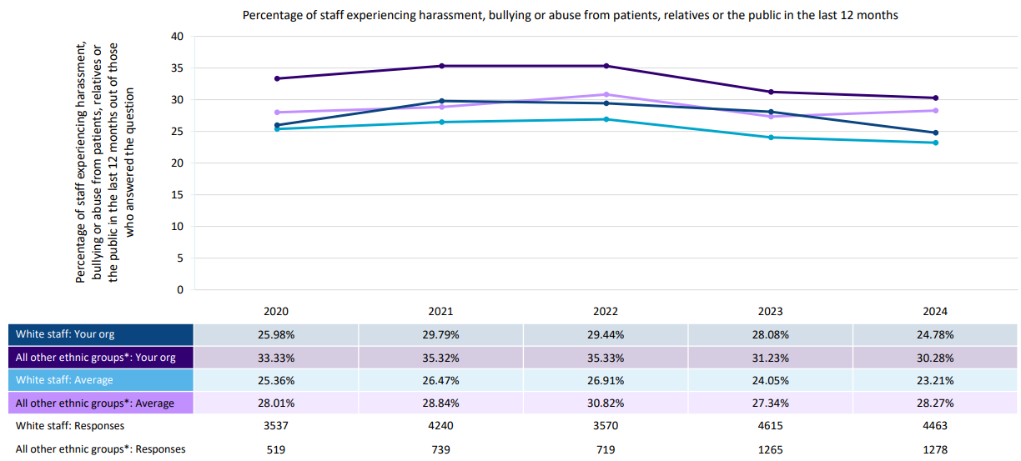

Analysis: Whilst there has been a steady improvement on this indicator over the past 3 years for both white and BME staff, of the respondents to the question there continues to be a higher proportion of BME staff experiencing bullying, harassment and abuse from patients, relatives and service users than white colleagues. Our figures are also around 1-2% higher than the national average when compared to similar sized Trusts.

WRES indicator 6 - Percentage of staff experiencing harassment, bullying or abuse from staff in last 12 months

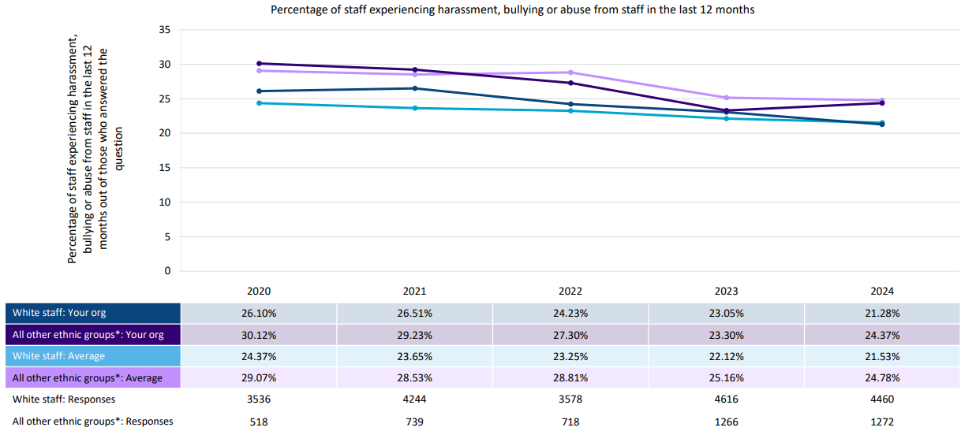

Analysis: Of the responders to the survey, the percentage of BME staff experiencing harassment, bullying or abuse from staff has increased by 1% when compared to the previous year and therefore a number of actions have been identified in the WRES Action Plan to try to address this.
WRES indicator 7 - Percentage of staff believing that their trust provides equal opportunities for career progression or promotion
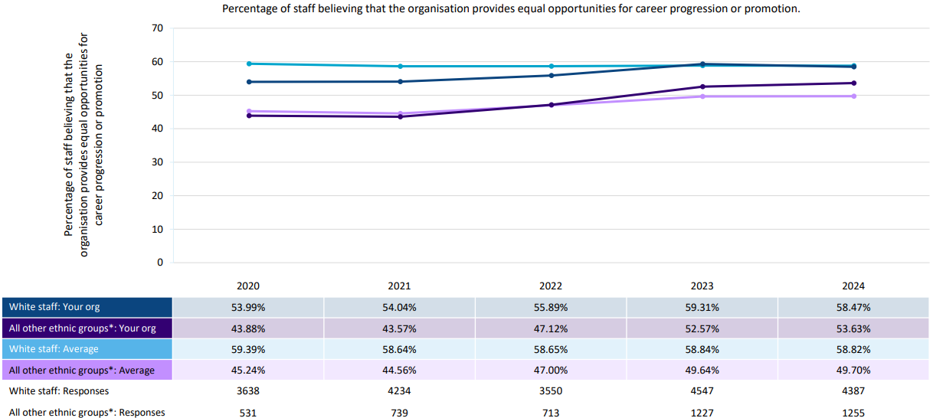
Analysis: Of the responders to the survey, there continues to be a steady increase in the number of BME staff believing they have equal opportunities for career progression or promotion (9.75% increase over the past 5 years, compared to 4.48% increase for white staff). However, ESNEFT aspires to bring the percentage closer to 70% of responders for both cohorts and again a number of actions have been identified within the Action Plan.

WRES indicator 8 - Percentage of staff experiencing discrimination at work from manager / team leader or other colleagues in the last 12 months
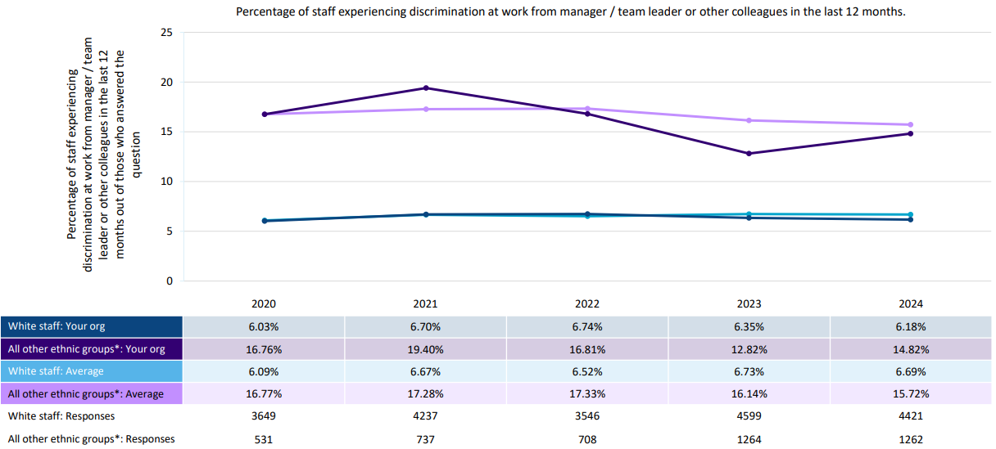
Analysis: There was a 2% increase in the number of BME staff experiencing discrimination at work from a manager/team leader when compared to the previous year and this is significantly higher when compared to the experience of White staff. A number of actions have been identified to address this.

WRES indicator 9 - The representation of BME people among board members

 |  | 2022 | 2023 | 2024 | 2025
Executive Board | BME | 0 | 0 | 0 | 0
Executive Board | White | 10 | 11 | 11 | 3
Non Executive | BME | 1 | 1 | 2 | 1
Non Executive | White | 8 | 7 | 6 | 15
Total |  | 19 | 19 | 19 | 19
 |  | 2022 | 2023 | 2024 | 2025
Voting | BME | 1 | 1 | 2 | 1
Voting | White | 13 | 14 | 8 | 15
Non-Voting | BME | 0 | 0 | 0 | 0
Non-Voting | White | 5 | 4 | 9 | 3
Total |  | 19 | 19 | 19 | 19

Analysis: The BME representation of all board members is not reflective of the workforce demographic and this has been consistent within the reporting of WRES data over the past 4 years. Whilst turnover in this staff group tends to be very low, there has been a concerted effort to attract a more diverse pool of candidates when appointing new board members, particularly when non-executive directors have reached the end of their tenure at the Trust.

Progress Over the Past Year:

Indicator 1 – Our Workforce: Our EMBRace staff network, which supports staff from ethnic minority background, have continued to provide amazing support to staff on inequalities relating to ethnicity by utilising their lived experience, knowledge and guidance to seek resolution. Quarterly members meetings have provided a safe space for staff to learn, share opinions and experiences, raise concerns and opportunity for their voices to be heard.
The network has also arranged a raft of events throughout the year to celebrate the wonderfully diverse workforce at ESNEFT. This has included an Asian Heritage Celebration day as well as Africa Day both of which were filled with colourful entertainment, delicious food and networking opportunities; Supported the Chaplaincy team to promote prayer rooms, washing facilities and a managers guide to supporting staff observing Ramadan; Recognising the rich and diverse cultures and contributions from various staff by promoting their profiles and stories to celebrate Black History Month; and Race Equality Week was celebrated with 5 daily challenges to raise awareness on how we can be more culturally aware and inclusive;
The Clinical Workforce and AHP Clinical Workforce teams have collaboratively implemented significant improvements to the on-boarding process for our internationally educated Nurses and AHP's, aiming to improve support around transition and integration into our organisation and the UK.
As part of these efforts, we now provide an International Welcome Guide prior to arrival, which includes essential information about the local area, our hospitals, access to health and wellbeing services and a number of practical how-to-guides.
Additionally, we have introduced a buddy programme, pairing new internationally educated Nurses and AHP's with established internationally educated colleagues for their first three months to support cultural integration and a supportive welcome. To further enhance support and psychological safety, we provide pastoral check-ins at three and six months, offering a safe space for discussions and signposting to wellbeing services.
The Wellbeing Team participates in the international nurses inductions to support their integration into ESNEFT. During each session, they deliver a presentation outlining the services available and providing guidance on stress management.

Recognising the unique challenges faced by our internationally educated colleagues, we have updated our Local Induction Standard Operating Procedure to include a three month settling in period before commencing their probation, allowing time to adjust to new systems and different ways of working within the NHS and ESNEFT. To support managers in creating a positive experience, we have developed a Managers Guide, offering tailored advice and best practice to effectively support staff during this transition, fostering a supportive and inclusive environment.

Indicator 2 – Our Recruitment Processes: Our Recruitment and EDI leads have worked closely over the past year to ensure that the recruitment processes are inclusive, welcoming and supportive from advertisement to on-boarding stage. We have continued to provide recruitment and selection training for all staff involved in a recruitment process and diverse interview panels for all Band 8+ roles as standard and for other bandings wherever possible. A recruitment drive for more Cultural Ambassadors was also undertaken with 18 staff expressing an interest and will support the recruitment process going forward.
Feedback is encouraged from everyone involved in the recruitment process so that we can continue to improve our services and ensure that selected candidates receive a fair and equitable process. The Recruitment team have been supporting recruiting managers to provide helpful, constructive feedback to any unsuccessful candidates upon request and signposting to development opportunities such as our leadership development programme, mentoring and coaching.
An audit was undertaken in April 2024 to gain assurance into why a lower number of applicants from ethnic minority background were appointed compared to white applicants. The audit found that a higher number had declined an interview with the main reasons being for personal reasons or they had secured another job elsewhere. The audit also looked into the higher numbers of applications from candidates from BME background compared to White candidates. It found that many BME applicants did not reach the minimum criteria requirements which provided further assurance that equitable and non-bias selection and decision making had occurred.
The Trust also receives a high number of applicants from ethnic minority background who do not meet the minimum criteria requirement. Further work will be undertaken to strengthen the narrative within our advertisements which we hope will avoid disappointment from repeat applicants who are not selected for shortlist, as well as enabling a more accurate and reflective data set when reviewing the number of applicants v shortlisted by ethnicity.
The Trust’s Recruitment and Selection Policy was reviewed earlier this year and provides an overview of the recruitment and selection practices to be followed with due regard to eliminating discriminatory behaviours and advancing equal opportunities. Recruitment and Selection training is also provided to all recruiting managers and interview panel members. In addition, our Cultural Ambassadors provide crucial observation and challenge on interview panels for all Band 8+ roles. A further 13 Cultural Ambassadors have been recruited to increase the current offer so that a diverse panel can be offered at interviews for Band 7 and below roles.

Indicator 3 – Our Formal Processes: The Employee Relations team have been working incredibly hard to resolve employee relation cases at informal stage either through additional support to managers in seeking an early resolution, or by providing mediation sessions. The competencies that our Cultural Ambassadors have over many of our support teams is their cultural lived experience which most definitely provides an enhanced understanding and connection with the individuals involved in processes and ultimately improves their experience. Our Cultural Ambassadors have also heavily supported the Employee Relations team and all of these interventions, we believe, have been is instrumental in preventing informal cases moving to formal process.
Sadly we have received some allegations of racist attitudes and discrimination relating to ethnicity over the past year and every concern raised has been taken seriously, with appropriate action and interventions to safeguard individuals and wellbeing support is provided to all those involved.

Indicator 4 - Non–mandatory Training and CPD : During the past year a project commenced to seek feedback from our internationally recruited staff to find out how many had or were considering undertaking further development training and to understand the reasons for them doing so. The survey commenced with the nursing cohort and results found that some staff felt it would improve their chances of promotion, whilst for others it was either a role requirement or personal development decision. The survey will be rolled out to other staff groups who have completed non mandatory training and CPD in the next year to get a rounded view of the experiences of staff groups and cohorts to ascertain whether the training provision they have chosen is fit for purpose or whether other options would have been more appropriate for them i.e. mentoring, coaching, networking, etc.
Indicators 5, 6 and 8 – Bullying, Harassment and Abuse: We have continued to focus on supporting staff to identify bullying, harassment, abuse and discriminatory behaviours with by continuing throughout the past year our Talk and Transform training initiative, derived from the University of Essex Dare to CARE (Creating an Anti-Racist Environment) project. These are impactful interactive sessions which raise awareness of racism, be it direct or systemic, the impact that racism has on individuals, and how to take action when witnessed. In addition to this, our suite of Equality, Diversity and Inclusion (EDI) training sessions include EDI bitesize, Active Bystander, LGBTQ+ and Disability Awareness, Sexual Safety, and bespoke intervention behavioural team sessions also continued throughout the year to educate and promote the benefits of intersectionality and inclusive cultures, ensuring that our behaviours, processes and policies are non-discriminatory and promote equality and equity of opportunities for everyone. Over 3000 staff participated in one or more of these sessions over the past year.
Our Freedom to Speak Up (FTSU) team was strengthened with the introduction of a deputy role and together they work closely with the FTSU Assistants and other key leads to promote the Raising Concerns policy and process, utilising our Cultural Ambassadors and allyship programmes, and wellbeing support provision. As a result, we have seen an increase in the number of concerns raised and going forward we feel there needs to be more focus on interventional work with senior leaders and managers to support them in identifying and addressing poor behaviours.
Other key actions included fully embedding the actions within the Race Equality Charter, reinvigorating our Zero Tolerance policy, and embedding compassionate and inclusive content within our Leadership Development Pathways to raise the profile of anti-racism and Trust’s aims to eliminate discriminatory behaviours trust wide.
We also launched Cohort 3 of our Reverse Mentoring Programme where junior staff mentored more senior staff on their lived experience of a protected characteristic and how leaders can support individuals better via safe, open and honest conversations. The 12 pairs who this programme found the experience incredibly thought-provoking, impactful and insightful.

Indicator 7 - Career Progression or Promotion: The Trust’s ambition is to see 70% of all responders to this staff survey question feeling that the Trust provides equal opportunities for career progression or promotion. There have been many projects and initiatives implemented to support staff with career progression and promotion, starting with the roll out of My Career Matters conversations which was designed to encourage career conversations between managers and their staff, creating pipe-lines of staff for potential gaps in workforce planning, a matrix to help individuals work towards or be ready for their next career move and signposting to development opportunities and resources they may need with clear goals and steps to achieve these.
The Trust has continued its Leadership Development Programme and a suite of management masterclasses. In addition to this, the Trust’s Women’s Network launched the Springboard Programme which is a personal development programme to learn how to be more assertive, confident, positive and in control of their work and home lives. Our EMBRace network supported in promoting the programme to its members and two cohorts of 25 women completed this hugely successful initiative.

Conclusion and Next Steps
This report highlights the progress we have made in advancing racial equality within our workforce, while also emphasising the areas where further work is required. The reductions in the levels of harassment, bullying, and abuse from the public, coupled with the increasing confidence of BME staff due to opportunities for career progression, are significant achievements that reflect our commitment to fostering a fairer and more inclusive environment. However, the findings also remind us that the journey towards achieving complete racial equality is ongoing.
The lived experiences shared by our staff provide essential insights that will continue to inform our approach, helping us to drive the cultural and systemic changes needed for sustained progress. We must remain vigilant in our efforts, ensuring that race equality is consistently prioritised in all areas of our work.
A number of areas of focus have therefore been identified and will be taken forward over the next year:
- Recruitment – further review into inclusive recruitment processes and practices including inclusive yet clear and concise advertisements; surveys to capture the experiences of our staff when going through the recruitment process to see where we may need to improve our current service; and supporting managers with My Career Matters conversations for staff who are ready for promotion.
- Employee Relations – Enablers to obtain feedback into staff experience when concerns are raised to better understand behavioural and systemic barriers faced by staff from ethnic minority background to determine areas of focus for further intervention or where our processes may be a point of failure.
- Culture - focussed cultural audits and interventional work with senior leaders and managers to support them in identifying and addressing poor behaviours; Continuation of the active bystander training and further work around FTSU and allyship alongside team support and interventions; and continuation of our Retention work particularly around internal movers.

Appendix 1 – ESNEFT Workforce – Clinical v Non-Clinical
