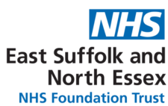
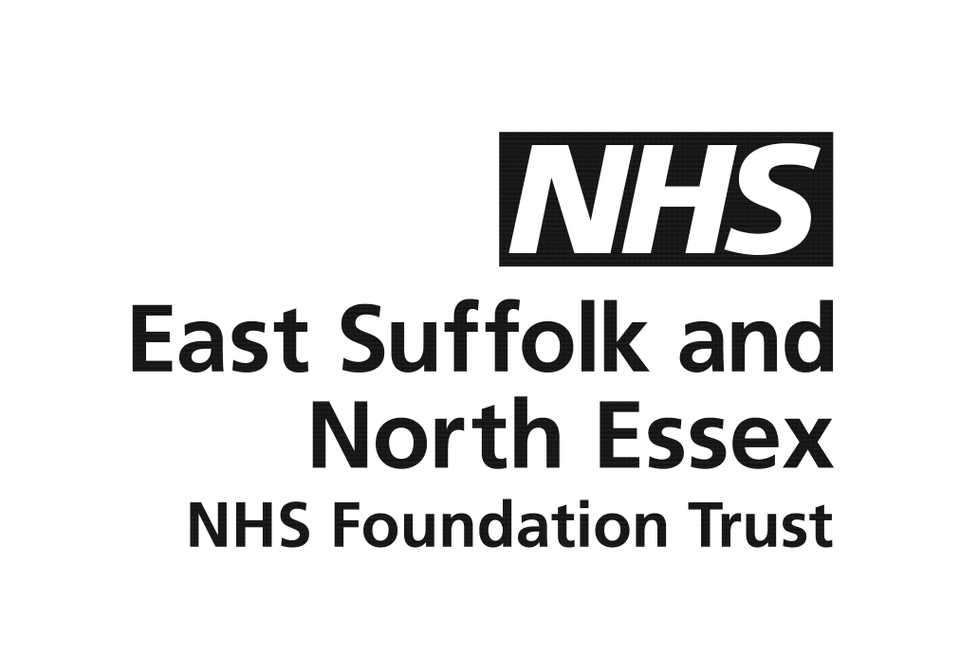
WORKFORCE DISABILITY EQUALITY STANDARD (WDES)
2024/25 ANNUAL REPORT

CONTEXT

The NHS Workforce Disability Equality Standard (WDES) is published annually and is an essential tool in supporting the Trust to be an accessible, inclusive and fair workplace. The report utilises data from the electronic staff record and the NHS Staff Survey to bring together a Trust wide picture of disability needs across the organisation.
It helps evaluate progress and identify areas where further improvement is needed, ensuring employees with a disability or long term condition have equal access to career opportunities and receive fair treatment in the workplace. This is important because studies show that a motivated, included and valued workforce helps deliver high quality patient care, increased patient satisfaction and better patient safety.
The WDES is built around 10 evidence-based measures (metrics) which enable NHS organisations to compare the workplace and career experiences of disabled and non-disabled staff.
The NHS England’s equality, diversity and inclusion improvement plan, published in 2023, sets out six actions which have been implemented and embedded within the Trust EDI Strategy Action Plan to create an environment where staff feel they belong, can safely raise concerns, and are empowered to deliver the best care to our patients. The annual WDES reporting is not only a statutory reporting requirement, but it also is a key enabler for continuous improvement in workforce disability equality through consistent data monitoring, trust wide accountability and shared good practice.

The WDES 2024/25 report is the latest version; previous years reports can be found on the Trust’s website: ESNEFT WDES library

INTRODUCTION

With nearly 1 in 4 people working in the NHS having lived experience of a disability or long-term condition, this year’s WDES report highlights significant progress made over the past 3 years to create a more inclusive and equitable working environment but also brings attention to the challenges we still face.

Whilst 76.85% of the Trust’s national staff survey responders who are disabled reported that the Trust made reasonable adjustment(s) to enable them to carry out their work, disabled staff remain more likely to feel pressurised to come to work when they do not feel well enough, and are experiencing higher levels of harassment, bullying or abuse compared to their non-disabled colleagues. Likewise, we also know that there is still work to be done to make sure all staff feel satisfied with the extent to which the organisation values their work.

We know that to achieve the goals set out for our staff in the 10 Year Health Plan, we must enhance the experience of our workforce, improving retention and attracting new talent to the Trust from the widest possible pool. Therefore our journey toward achieving equality is ongoing and this report represents an important step in holding the Trust accountable, ensuring transparency and driving the systemic change needed for a more inclusive future.

KEY FINDINGS

WDES Indicator 1 - Percentage and number of staff by disability

The ESNEFT workforce snapshot of 31 March 2025 showed that the Trust had a workforce of 12,991 (an increase from previous year: 12,379), of which 7.24% disclosed a disability or long term condition (6.37% previous year) and a non-disclosure rate of 1.66% (8.85% previous year). This has been a positive trend over the past 3 years due to a more robust data capture at the point of recruitment and targeted internal communications around the importance of disclosure.

Below is a snapshot of ESNEFT staff by disability status as of 31 March 2024/25 compared to 2023/24:
Band | 2023/24 |  |  |  | 2024/25
Band | Disability | No Disability | Not disclosed | % Disability p/band | Disability | No Disability | Not disclosed | % Disability p/band
1 | 1 | 29 | 39 | 1.44% | 1 | 57 | 0 | 1.72%
2 | 117 | 1199 | 166 | 7.89% | 115 | 1292 | 15 | 8.87%
3 | 133 | 1922 | 163 | 6.00% | 169 | 2170 | 26 | 7.15%
4 | 87 | 834 | 61 | 8.86% | 94 | 881 | 22 | 9.43%
5 | 135 | 2031 | 162 | 5.80% | 172 | 2261 | 40 | 6.96%
6 | 134 | 1721 | 149 | 6.69% | 172 | 1976 | 28 | 7.90%
7 | 88 | 1149 | 93 | 6.62% | 102 | 1241 | 28 | 7.44%
8a | 19 | 323 | 30 | 5.11% | 31 | 365 | 9 | 7.65%
8b | 8 | 123 | 11 | 5.63% | 6 | 144 | 2 | 3.95%
8c | 1 | 61 | 1 | 1.59% | 1 | 58 | 1 | 1.67%
8d | 3 | 30 | 1 | 8.82% | 3 | 33 | 0 | 8.34%
9 | 1 | 15 | 1 | 5.88% | 1 | 16 | 0 | 5.89%
VSM | 2 | 23 | 0 | 8% | 1 | 20 | 0 | 4.76%
Trainee Grade | 37 | 395 | 46 | 7.74% | 43 | 463 | 16 | 8.24%
Non-consultant career grade | 6 | 276 | 35 | 1.89% | 9 | 331 | 6 | 2.60%
Consultant | 16 | 364 | 138 | 3.09% | 15 | 507 | 23 | 2.75%
Total | 788 | 10495 | 1096 | 6.37% | 941 | 11834 | 216 | 7.24%
NB: Appendix 1 shows the breakdown of clinical v non-clinical staff.

Analysis: The largest representation of staff with a disability is in Bands 3, 5 and 6 and they also have the higher number of non-disclosure. There is a higher ratio of disabled staff compared to non-disabled staff in Bands 2, 4, 8d and Trainee grades. However, the disclosure data indicates that staff with a disability are disproportionately underrepresented in Band 1 and the lowest representation at Band 8c of 1.67%.

WDES Indicator 2 - The relative likelihood of non-disabled candidates compared to disabled candidates being appointed from shortlisting across all posts
 | 2023/24 |  |  | 2024/25
 | Disabled | Non  Disabled | Unknown | Disabled | Non  Disabled | Unknown
Number of shortlisted applicants | 562 | 4853 | 148 | 555 | 4873 | 189
Number appointed from shortlisting | 215 | 1812 | 140 | 329 | 3056 | 140
Relative likelihood of non-disabled candidates being appointed from shortlisting compared to disabled Staff | 0.98 |  |  | 1.06

Analysis: We can see a slight shift in the data over the past year which indicates the likelihood of non-disabled candidates being appointed from shortlisting across all posts compared to disabled candidates is just over the preferred 1:1 ratio and indicates that disabled candidates may be at a slight disadvantage.
WDES Indicator 3 - The relative likelihood of disabled staff entering the formal capability process compared to non-disabled staff
 | 2023/24 |  |  | 2024/25
 | Disabled | Non-Disabled | Disability Unknown | Disabled | Non-Disabled | Disability Unknown
Average No. of staff entering formal capability process over the last 2 years (Total divided by 2) | 2 | 16 | 6.5 | 5.5 | 33.5 | 3.5
Of these, how may were on the grounds of ill-health | 0.5 | 10.5 | 5 | 5 | 27 | 3.5
Relative likelihood of Disabled Staff entering formal capability | 3.63 |  |  | 0.97
Analysis: This figure has reduced significantly over the last two years (6.08 / 3.63 / 0.97) which is due to the continued work undertaken by our Employee Relations, Cultural Ambassadors, Occupational Health and Wellbeing teams to support individuals as well as divisions which have impacted on the number of formal cases this year. A figure above 1:00 indicates that disabled staff are more likely than non-disabled staff to enter the formal capability process therefore this indicates that the dedicated work has had a positive impact on staff experience and outcomes.

5 Year Comparison of WDES Indicators 1-3

The table below is a 5 year comparison of indicators 1-3 which shows a steady increase in the number of staff disclosing a disability from 2021-2025 which is in line with our Equality, Diversity and Inclusion Strategy ambition to have a diverse workforce that is provided with equal opportunities and is well supported at ESNEFT. Indicator 2, indicates a slight disadvantage to candidates with a disability and the spot check recruitment audits will continue to provide assurance that our recruitment processes are fair and equitable. However Indicator 3 data indicates that significant progress has been made in maintaining a fair process for staff in terms of entering a formal capability process and when combining all 3 indicators, it shows that the Trust is heading in the right direction towards a more equal balance in terms of staff experience and opportunities.
 |  | 2020/21 | 2021/22 | 2022/23 | 2023/24 | 2024/25
Indicator 1 | No. of staff at the Trust | 10,809 | 11,635 | 11,829 | 12,379 | 12,991
Indicator 1 | % of staff with a disability/LTC at the Trust | 1.61% | 2.93% | 5.21% | 6.37% | 7.24%
Indicator 2 | Relative likelihood of white staff appointed from shortlisting compared to disabled staff | 0.73 | 1.24 | 0.88 | 0.98 | 1.06
Indicator 3 | Relative likelihood of disabled staff entering formal capability process compared to white staff | N/A | 0.77 | 6.08 | 3.63 | 0.97

WDES Indicator 4a - Percentage of disabled staff experiencing harassment, bullying or abuse from patients, relatives or the public in the last 12 months
The data for Indicators 4-9 have been sourced from the National NHS Staff Survey which provides a comparison of the outcomes of the response for disabled and non-disabled staff: Local results for every organisation | NHS Staff Survey (nhsstaffsurveys.com)
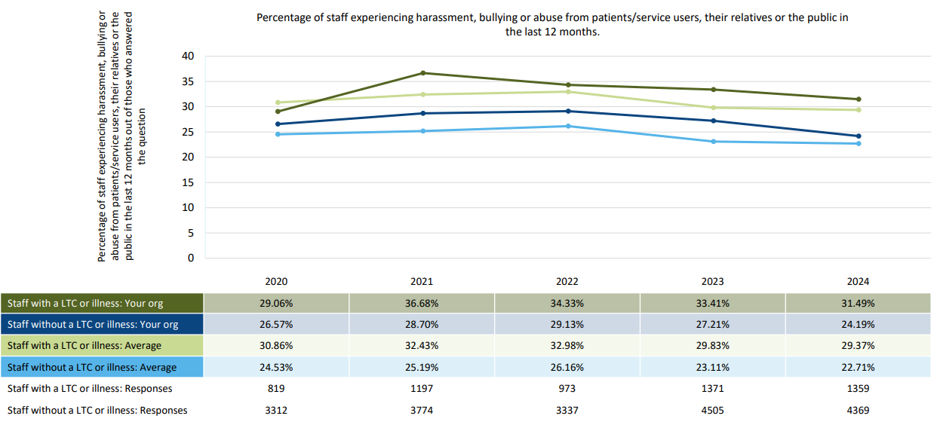
Analysis: Whilst the data is showing a steady improvement for all staff when asked if they had experienced bullying, harassment or abuse from patients, their relatives or the public, the percentage remains much higher for staff with a disability compared to staff without a disability and when compared to the national average.
WDES Indicator 4b - Percentage of disabled staff experiencing harassment, bullying or abuse from managers in the last 12 months
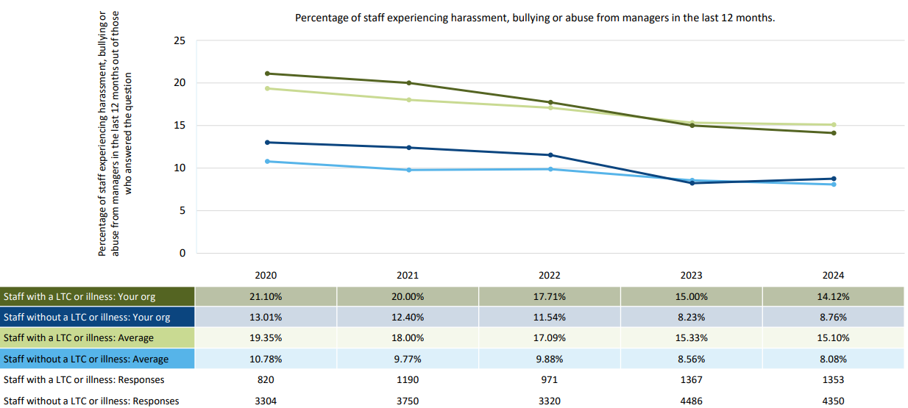
Analysis: Again we can see a steady reduction in the number of disabled staff experiencing harassment, bullying or abuse from managers over the past 5 years and this may be as a result of the increased awareness of the impact that such behaviours have on staff, and managers responsibilities around ensuring that their teams feel included and supported according to their individual needs.
WDES Indicator 4c -Percentage of disabled staff experiencing harassment, bullying or abuse from other colleagues in the last 12 months
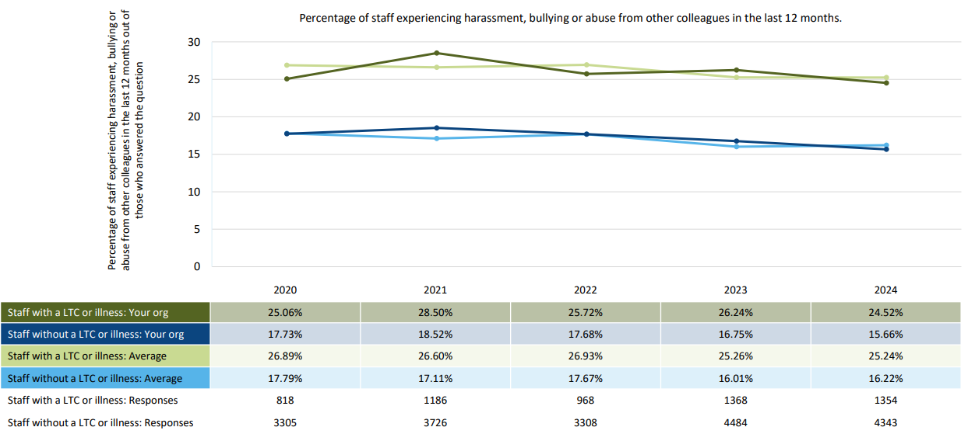
Analysis: Similarly, we can see the positive downward trend in the percentage of staff experiencing harassment, bullying or abuse from other colleagues, and this is again below the national average. However there is a significant difference between the experiences of disabled staff compared to non-disabled staff and this is certainly an area of focus required over the next year.

WDES Indicator 4d - Percentage of disabled staff who indicated that they or a colleague reported the last incident of harassment, bullying or abuse experienced at work
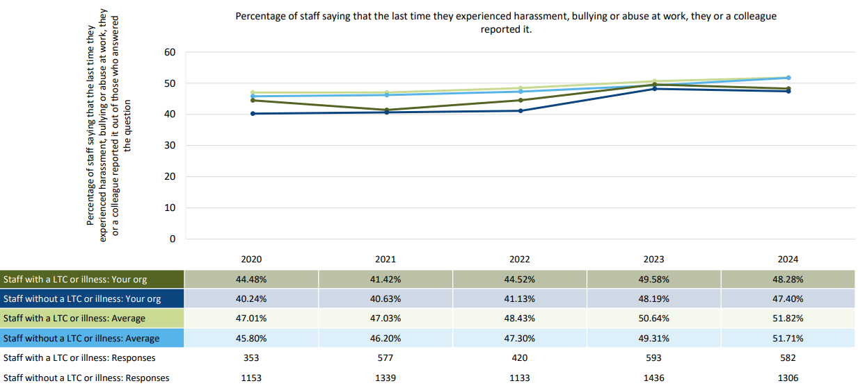
Analysis: We can see a slight drop in the number of staff reporting an incident of harassment, bullying or abuse experienced at work for both staff with a disability or no disability, and although both figures are below the national average, this may signify further work required around psychological safety and/or confidence that appropriate action will be taken.
WDES Indicator 5 - Percentage of disabled staff believing that their trust provides equal opportunities for career progression or promotion
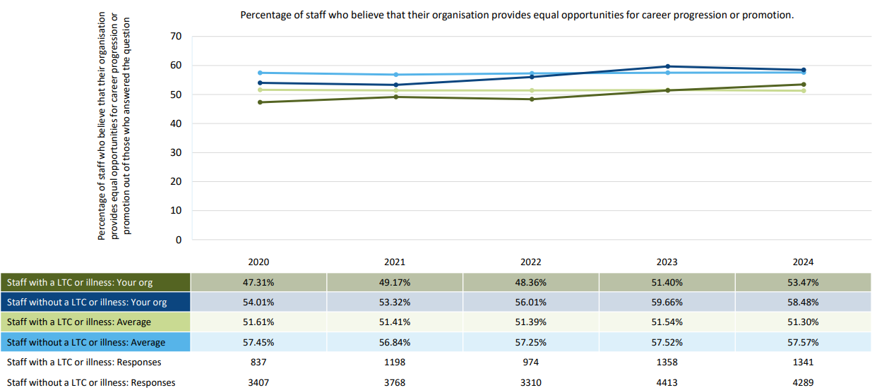
Analysis: The data shows a positive increase in staff believing they have equal opportunities for career progression or promotion for staff with a disability and this is higher than the national average. However the percentage is 5% higher for staff without a disability.
WDES Indicator 6 - Percentage of disabled staff who said that they have felt pressure from their manager to come to work despite not feeling well enough to perform their duties
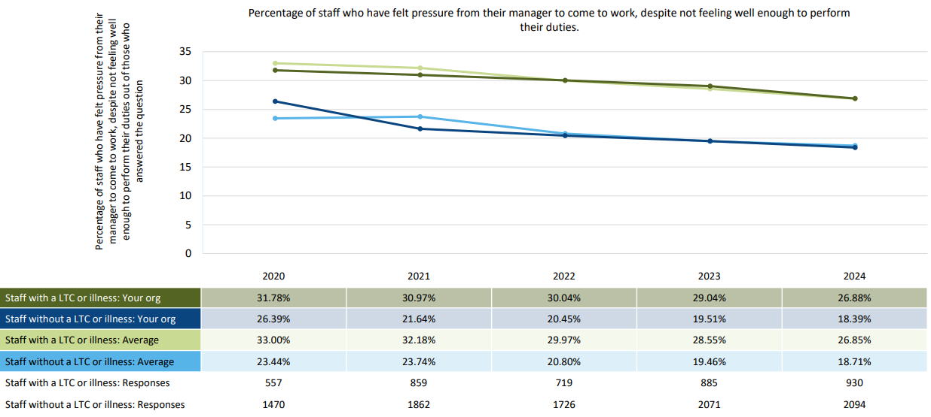
Analysis: Whilst the data shows a slight improvement in the number of staff feeling pressure to come to work despite not feeling well enough to perform their duties, there is a stark difference in experiences of staff with a disability compared to those without and again, further work is needed to understand the reasons for this.

WDES Indicator 7 - Percentage of disabled staff saying that they are satisfied with the extent to which their organisation values their work
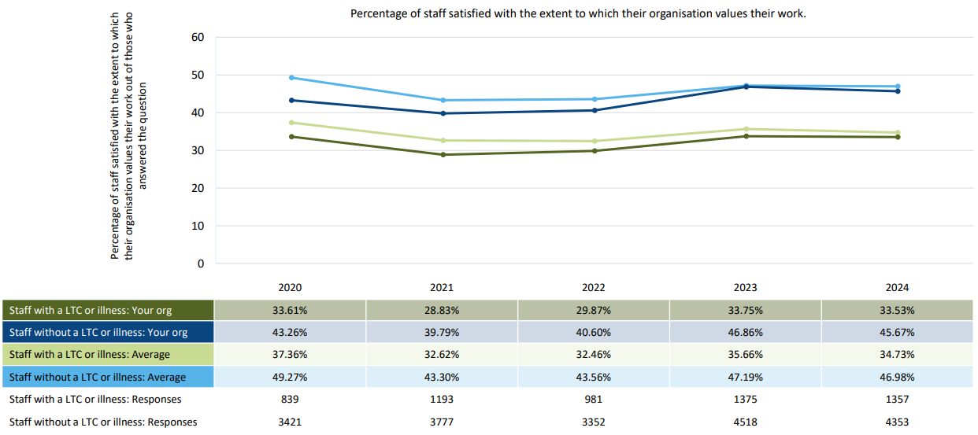
Analysis: We can see that the number of staff with a disability feeling satisfied with the extent to which the organisation values their work, whilst has not changed much in the past year, is significantly lower than staff without a disability.
WDES Indicator 8 - Percentage of disabled staff saying that their employer has made reasonable adjustment(s) to enable them to carry out their work
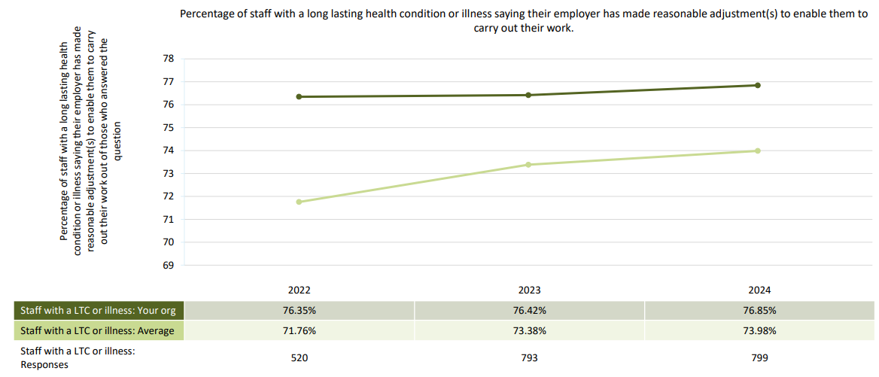
Analysis: The percentage of staff with a disability or long term condition saying the Trust has made reasonable adjustment(s) has remained the same over the past 3 years even though there has been a lot of work around educating staff and managers around the requirement to put adjustments in place. However it should be noted that the Trust’s figures have remained higher than the national average.

WDES Indicator 9 - Staff engagement scores
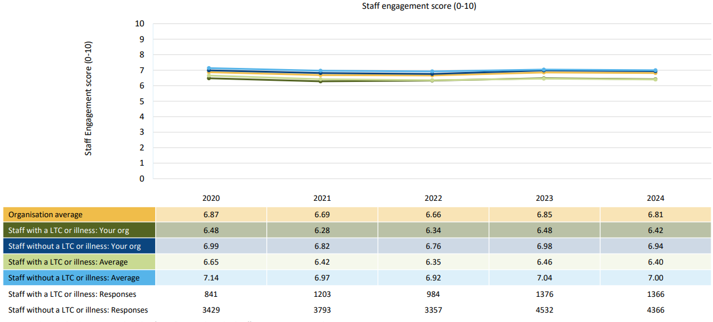
Analysis: Again the engagement score has remained fairly consistent over the past 5 years and is slightly above the national average. This had been identified as one of the areas of focus over the next year within the organisational development action plan.
WDES indicator 10 - Disability representation among board members

Analysis: Disclosure has remained good within this cohort and the Board level representation of members with a disability is 10.52% which is higher when compared to the Trust wide figure.

Progress Over the Past Year:

Indicator 2 – Recruitment Processes: The Recruitment Team have been working exceptionally hard to ensure that the recruitment process is inclusive and the needs of candidates with a disability are met. The Recruiting People with a Disability or Long Term Condition (LTC) Policy was reviewed and strengthened to support recruiting managers to think about the various considerations and approach to the recruitment process in terms of supporting candidates and potential new starters who have a disability or LTC. This included drafting interview questions in a timely manner for dissemination prior to interview when requested, booking accessible and adaptable venues, and allowing adequate breaks within the interview schedules.
The Recruitment and Equality, Diversity and Inclusion Leads have also continued to work collaboratively with Essex Cares Ltd (ECL) following the signing of an MOU to support people with a disability to obtain paid work at the Trust. This focusses on individuals with neurodiverse conditions and provides a bespoke process in terms of application, preparation and reasonable adjustment support.
Indicator 3 – Formal Processes: There has been continued collaborative work between our Employee Relations, Cultural Ambassadors, Freedom to Speak Up Guardians, Occupational Health and Wellbeing teams to support individuals involved in an informal case and their line managers which has often prevented it moving to formal process. In addition, these teams have supported divisions in reviewing long term sickness cases, which have impacted positively on the both the individuals, the departments as well as reducing the number of formal cases this year.
Indicator 4 - Harassment, Bullying or Abuse: Positive feedback was received from the Disability Awareness training sessions which was provided by the superb subject expert, Rocket Girl. The sessions aimed to educate and eliminate discrimination against disabilities and support all staff and managers in order to widen the understanding of what constitutes as a disability, recommendations to consider in the workplace when supporting an individual with a disability and signposting to external guidance and support.

In addition to this, one of our amazing Clinical Practice Education Facilitator Leads has been raising awareness of the needs of staff with neurodiverse conditions. They have reviewed existing support measures and identified any gaps in awareness and support, such as reasonable adjustments, and remove the stigma of disclosure. As a result, multiple initiatives have been launched, including the development of a dedicated staff intranet page offering resources and guidance for various neurodiverse conditions, along with the creation of accessible Padlets. Building on these ongoing efforts, trust-wide Neurodiversity Awareness Training has been rolled out for all staff. Additionally, we are in the process of developing specialised training for line managers to enhance their ability to support neurodiverse staff. We are also actively exploring assistive technologies in partnership with our IT colleagues.

Following a recruitment drive we now have 133 Wellbeing Ambassadors, 18 Cultural Ambassadors and alongside our Staffside representatives they provide a point of contact for staff if they experience any processes or behaviours which may be discriminatory or disadvantaging those with a disability or long term condition. They signpost to the appropriate teams in order to raise a concern, seek reasonable adjustment and/or wellbeing support.

Indicator 5 - Career Progression or Promotion: Our Training and Development team have been looking at various ways to provide the in-house training programmes to make them as accessible as possible for all staff.

Indicator 8 – Reasonable Adjustments: The review of the Reasonable Adjustment (RA) Passport and supporting guide has been underway with a working group consisting of key staff from the Wellbeing, Occupational Health, Employee Relations, Staffside and EDI teams as well as members from our ESNAble Network to ensure that the review is taken through the lens of lived experience and expertise of a disability or long term condition. Both documents have been significantly strengthened to include different types of conditions that staff may have and the various adjustments that can be considered to support individuals in the workplace. The guide includes a more robust and clear RA process to strengthen support to both managers and staff with a condition so that they can work to their best ability in a safe environment.
In addition, the Health and Safety Team have been proactively looking at accessibility across all ESNEFT sites, ensuring that entrances into our buildings are accessible with wide, automatic doors and ramps as well as supporting with Display Screen Equipment (DSE) and environment assessments and providing advice on relevant reasonable adjustments for staff.
Indicator 9 - Staff engagement: We have raised the profile of the Trust’s ESNAble Staff Network, which aims to support staff with a disability or long term condition, by promoting the network at staff inductions, various in-house events, and regular stands across each site as well as quarterly members meetings enabling a safe space for disabled staff voices to be heard, valued and supported at ESNEFT. The Network leads provide excellent lived experience, support and guidance to staff who wish to raise a concern or seek support with any environment issues or behaviours that may be causing barriers and preventing them being their very best in the workplace.

Conclusion and Next Steps

The following areas of focus over the next year are:

Culture
- Roll out of the Disability Awareness training from the New Year to help educate all staff and managers on the various disabilities and how these impact on individuals in the workplace, what support and adjustments can and should be made to help foster good relations between cohorts of staff and eliminate harassment, bullying or abuse from other colleagues.

- Continue with the ESNAble Network members meetings and live chat room as well as the Disability Working Group, which provide staff with a disability to seek support and have their voices heard.

Reasonable Adjustments

- Robust communication plan for the revised RA passport and supporting guide and work with operational areas to better understand their workforce profile in terms of disability and support provision with engagement activities for disabled and non-disabled staff and to learn about barriers and promote a better understanding of, and learnings associated with, living with a disability or long term health condition.

Processes
- The Employee Relations Team to conduct a deep dive into the outcomes of the capability cases to provide assurance around the internal processes in terms of individuals being adequately supported in their wellbeing, reasonable adjustment requirements, and redeployment options (where it is deemed appropriate).

- Continuation of work to support Level 3 Disability Confident Employer status

- Continually review feedback from the EDI focused learning and development training sessions to ensure it remains fit for purpose and that our current workforce processes adequately support all cohorts of staff.

Appendix 1 – ESNEFT Workforce – Clinical v Non-Clinical
